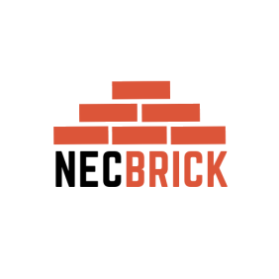**NATIONAL EMPLOYMENT COUNCIL FOR THE BRICKMAKING AND**

**CLAY PRODUCTS MANUFACTURING INDUSTRY**

House No 1976 Area D Westgate, HARARE Cell: 0771263752, 0771616057

23 April 2024

To: All Stake Holders

And

To: All Clients

And

To: Whom it may concern

**NOTICE OF CHANGE OF PHONE NUMBERS FOR OUR NEC.**

The above captioned matter refers.

Please note that we are changing our phone numbers with immediate effect. Our new phone numbers are:

**RECEPTION-0771616057**

**ACCOUNTANT-0771586176**

**DA-0771307179**

**A. GENERAL SECRETARY-0771263752**

May we all be guided accordingly.

Yours Faithfully

E.R Munemo

**A. GENERAL SECRETARY**